**Creating NIC Bonding:**

* Add a new NIC if it does not exist
* Install bonding driver = **modprobe bonding**
* To list the bonding module info = **modinfo bonding**

*You will see the driver version as seen below if the driver is installed and loaded*

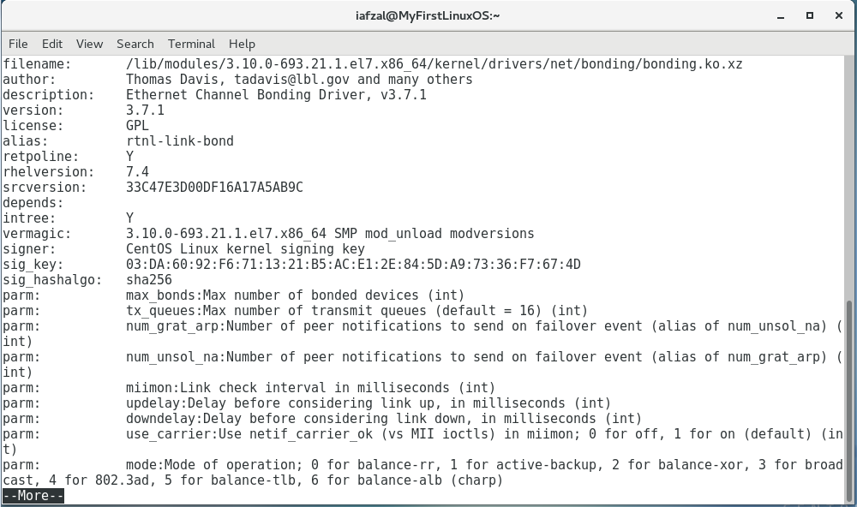

Create Bond Interface File

* vi /etc/sysconfig/network-scripts/ifcfg-bond0
* Add the following parameters

**DEVICE=bond0**

**TYPE=Bond**

**NAME=bond0**

**BONDING_MASTER=yes**

**BOOTPROTO=none**

**ONBOOT=yes**

**IPADDR=192.168.1.80**

**NETMASK=255.255.255.0**

**GATEWAY=192.168.1.1**

**BONDING_OPTS=”mode=5 miimon=100”**

* Save and exit the file
* The bonding options details are can be found on the following table

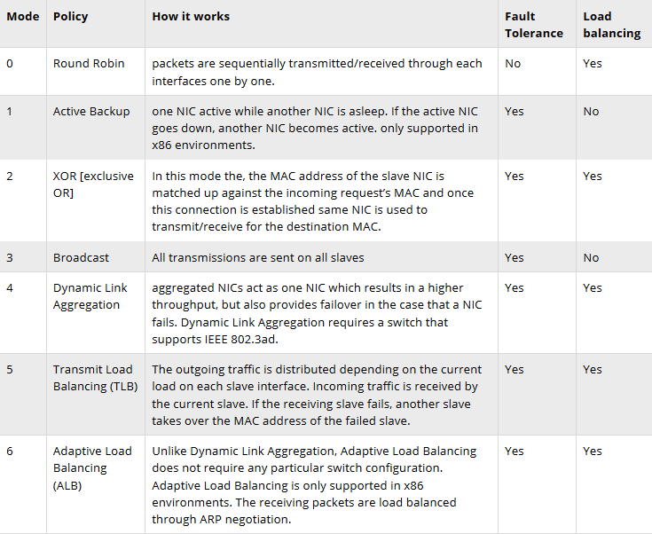

**miimon**

Specifies the MII link monitoring frequency in milliseconds. This determines how often the link state of each slave is inspected for link failures

Edit the First NIC File (enp0s3)

* vi /etc/sysconfig/network-scripts/ifcfg-enp0s3
* Delete the entire content
* Add the following parameters

**TYPE=Ethernet**

**BOOTPROTO=none**

**DEVICE=enp0s3**

**ONBOOT=yes**

**HWADDR=”MAC from the ifconfig command”**

**MASTER=bond0**

**SLAVE=yes**

* Save and exit the file

Create the Second NIC File (enp0s8) or Copy enp0s3

* vi /etc/sysconfig/network-scripts/ifcfg-enp0s8
* Add the following parameters

**TYPE=Ethernet**

**BOOTPROTO=none**

**DEVICE=enp0s8**

**ONBOOT=yes**

**HWADDR=”MAC from the ifconfig command”**

**MASTER=bond0**

**SLAVE=yes**

* Save and exit the file

Restart the Network Service

* **systemctl restart network**

Test and verify the configuration

* **ifconfig or ifconfig | more**

Use following command to view bond interface settings like bonding mode & slave interface

* **cat /proc/net/bonding/bond0**